TRAINING ADVISER GUIDE – SOMERSET COUNTY DATABASE
Once a learning module has been validated, it should be recorded, as soon as practicable onto the Somerset County Database. This ensures that a record is maintained which, is captured and advised to the Local Training Manager on a weekly basis. The LTM then makes the appropriate record on COMPASS.
In order to access the relevant section of the County Database, please search the LEADER box by typing in the full name and press SEARCH or CLICK ON THE NAME DISPLAYED
From the Leader landing page, select the TRAINING heading from the left hand menu
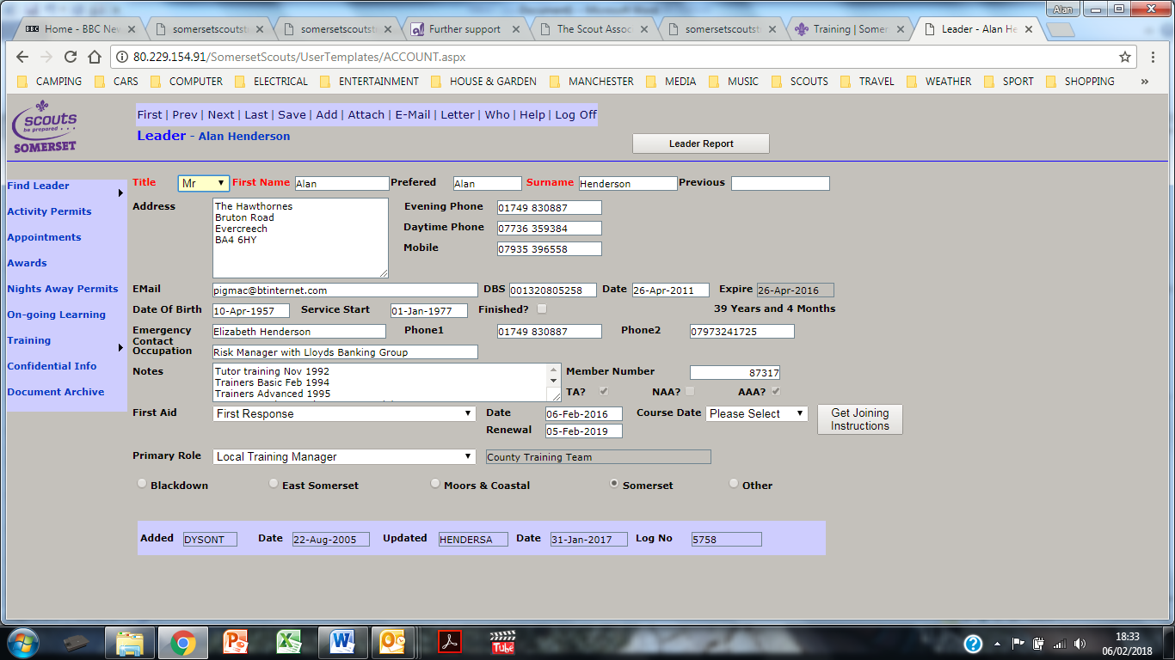
This should launch the training scheme in operation. If a choice menu is displayed, select the appropriate scheme.
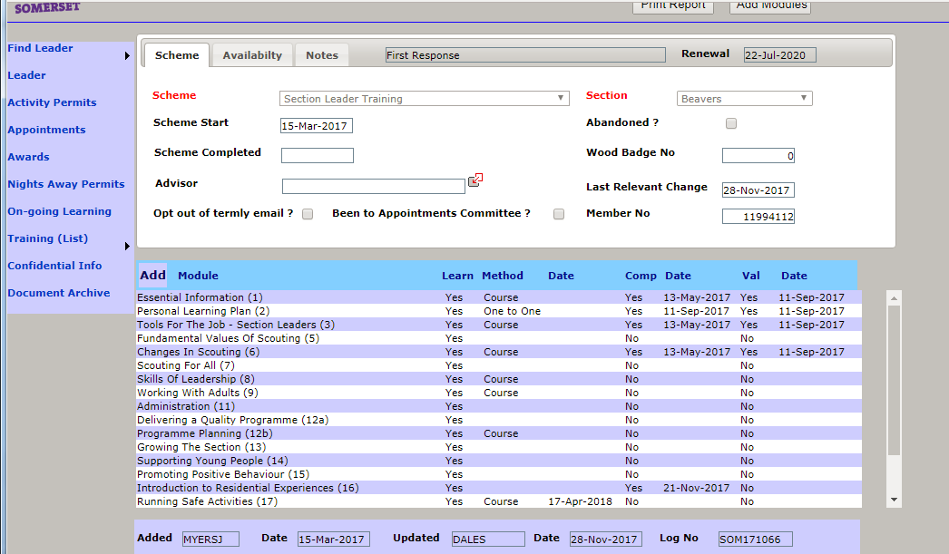
You might need to scroll down to reveal the module required.
If the learner has completed a course, the date will be pre filled. If they have completed the learning by e-learning, workbook or where prior learning or no learning is required, you will need to complete the details.
Click on the module to reveal the completion screen as follows
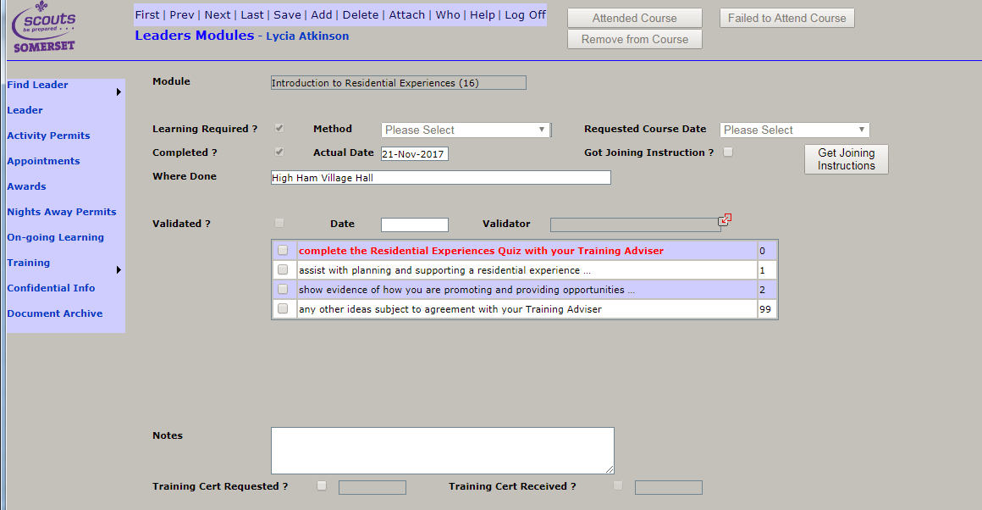
Complete the following
- Method (if applicable from drop down)
- Date completed (Actual Date)
- Validator – a drop down menu will allow you to find your name to click
- Validation Date
- Validation criteria – tick those appropriate. Note, if in red, it must be completed. Otherwise, the TA Guide will let you know how many validation criteria are required.
- Notes – if applicable, you can add notes in free format area.
DO NOT FORGET TO SAVE THE DATA BY SELECTING “SAVE” FROM THE TOP LINE MENU
THOSE ARE THE ONLY COMPLETION AREAS THAT YOU NEED CONCERN YOURSELF WITH.
The information will be extracted weekly and sent to the LTM however, you will also need to complete the individuals Personal Learning Plan document so that they can see what has been completed.
You may also want to complete the module summary and mail to your LTM.

