SOMERSET COUNTY SQUIRREL DAY
SUNDAY 10th May 2026
Group Booking Form
Leaders in charge:
Tricia Sedgbeer

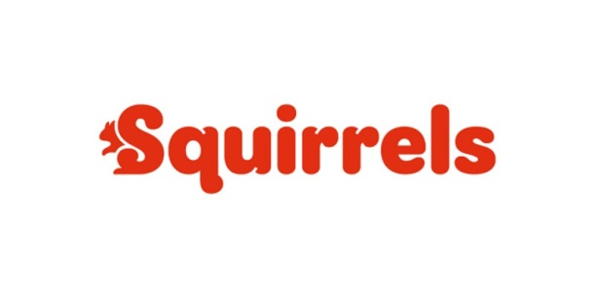
District
Drey / Group

Contact telephone no.
Leader in charge

Payment made by BACS or Cheque.
Amount £
Email address

Name of Squirrel | Allergies/special needs | Photo  Yes/No
Squirrels cost £15.00 each

Other leaders/young leaders/helpers Allergies/special needs/medical details

……………………………………………………………………………………………………………….
…………………………………………………………………………………………………………...........

………………………………………………………………………………………………………………...

...........................................................................................................................................................................

...........................................................................................................................................................................

...........................................................................................................................................................................
Leaders are free of charge at a ratio of 1:4 Squirrels. Any additional leaders/young leaders will need to pay an admission fee of £12.00

……………………………………………………………………………………………………………......

…………………………………………………………………………………………………………………

Name of your In Touch contact Contact numbers

