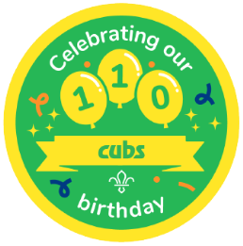

Somerset County Cub Day 2026
Crealy Theme Park – 110th Birthday

Date: Saturday 16th May 2026
Location: Crealy, Sidmouth Road, Clyst St Mary, Exeter. EX51DR
Time: Arrive for a 10am start - groups can be booked in at the main entrance from 9.45am. The day will finish at 4.00pm
Cost: £17.50 per Cub which includes a Cub Day badge and a birthday gift bag.
Leaders are free of charge at a ratio of 1:8 – any additional leaders/young leaders will need to pay an admission fee of £15.00
Home Contact All Cub Packs will need to arrange their own In-Touch.
Requirements
- All Cubs and leaders need to wear full uniform and/or a group t-shirt and scarf.
- Bring a packed lunch, drink, and coat.
- First aid facilities are provided at the venue, but it is advisable to bring a small/travel kit for minor incidents.
- Leaders will be responsible for the health forms of the young people during the visit.
The County Programme Team will be taking photos at the event to promote Scouting, these will be published on the Somerset Scout County web site, and social media pages, if any of your Cubs are unable to have photos taken please identify them on the booking form, and a Green Neckerchief will be given to them to wear for the day

For more information about the attractions please visit www.crealy.co.uk

If your pack would like to join us at Crealy on Saturday 16th May 2026, please express your interest by contacting me, before 31st March 2026, by email programme@somersetscouts.org.uk to confirm approximate numbers for your pack, and then send the completed booking form, and payment covering the fee, by 1st May 2026

Payment should be sent by Faster Payment to:
- Account Name: Somerset County Scout Council
- Sort Code: 30-98-45
- Account Number: 69926560
- Reference: CFD26 and your Group name
If paying by Group cheque please send to:
- Tricia Sedgbeer 2 Crown Lane Creech, Heathfield, TAUNTON TA3 5EU
- Cheques should be made payable to Somerset County Scout Council.
If you have any questions or need further clarification please do not hesitate to contact me

Regards

Tricia Sedgbeer
County Programme Team Lead
Somerset County Scouts
Tel: 01823-412258 Mob: 07528-748488
E-mail:programme@somersetscouts.org.uk

